**Name: Kanak Agrawal**

**Email:** [Kanakagrawal2001@gmail.com](mailto:Kanakagrawal2001@gmail.com)

**Date:** 30-01-2024

**Python Day-2**

**Question:** Reading data from CSV file into python lists

**Answers:** CSV stands for “Comma Separated Values.” It is the simplest form of storing data in tabular form as plain text.

Methods to read a CSV file

1. **Using csv.reader**

**Code:** 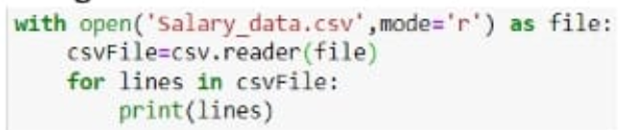

**Output:**

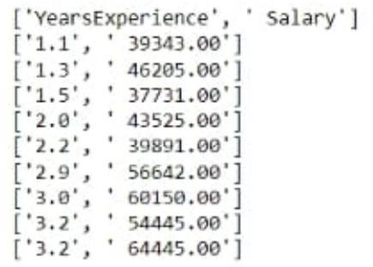

1. **Using csv.DictReader**

**Code:**

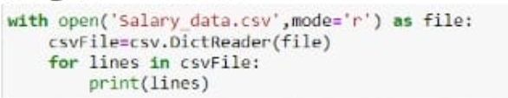

**Output:**

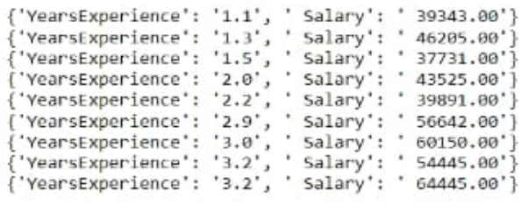

1. **Using .readlines() function**

**Code:**

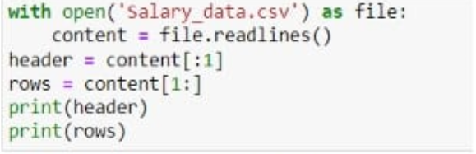

**Output:**

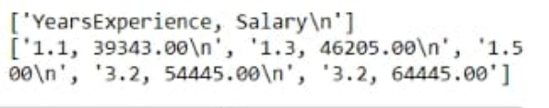

1. **Using Pandas**

**Code:**

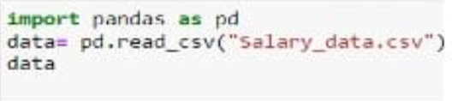

**Output:**

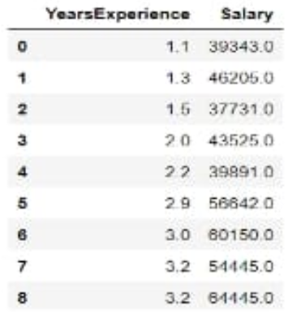

**Methods to write a CSV file in python**

1. **Using writelines() function**

**Code:**

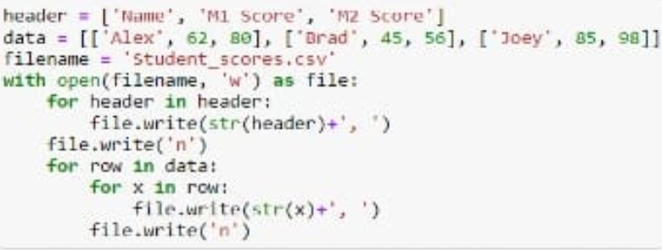

**Output:**

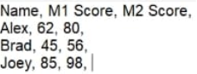

1. **Using csv.write**

**Code:**

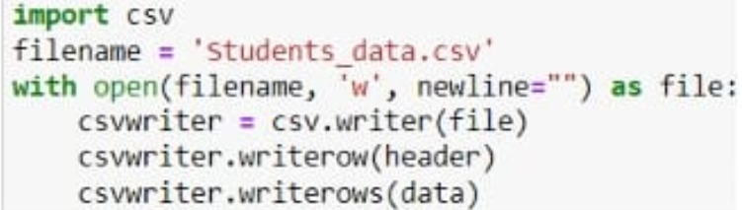

**Output:**

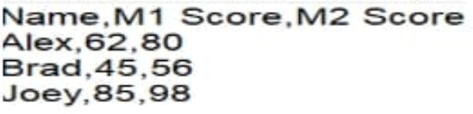

1. **Using Pandas**

**Code:**

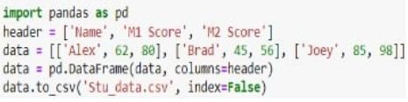

**Output:**

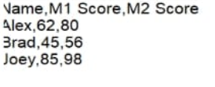

1. **Using csv.DictWriter**

**Code:**

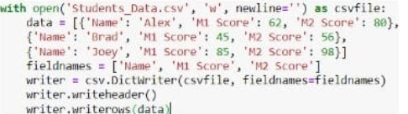

**Output:**

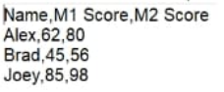

**Question:** Lambda Function in python

**Answer:** A lambda function is a small anonymous function. Lambda function can take any number of arguments, but can only have one expression.

**Syntax:** lambda arguments: expression

**Code & Output:**

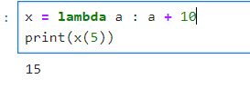

**Code & Output:**

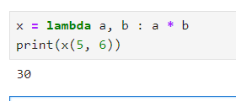

**Question:** Filter data in python lists using filter and reduce.

1. **Use of lambda function in python**

**Code & Output:**

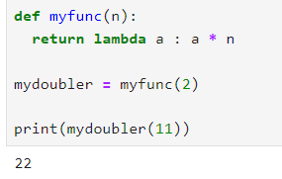

**Code & Output:**

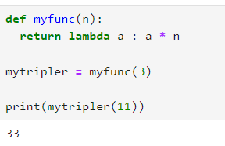

1. **practical uses of python lambda function**

* Lambda function with list comphersion

**Code & Output:**

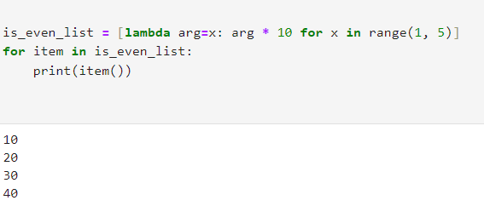

* Lambda function with multiple statement

**Code & output:**

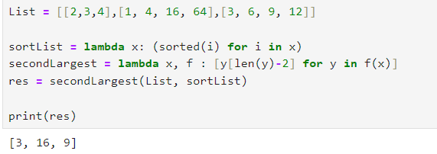

1. **using lambda function with map, filter, reduce**

* **Lambda function with filter()**

The filter() function in Python takes in a function and a list as arguments.

**Code & Output:**

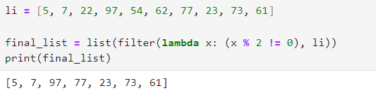

* **Lambda function with map ()**

The map() function in Python takes in a function and a list as an argument. The function is called with a lambda function and a list and a new list is returned.

**Code & Output:**

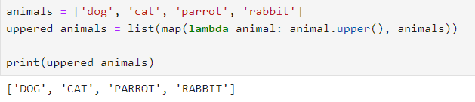

* **Lambda function with reduce()**

This performs a repetitive operation over the pairs of the iterable.

**Code & Output:**

